How to Trade Both Trend and Range Markets by Single Strategy?
S. A Ghafari

What Happened to Me?
Seven years ago when I was about to finish a long time study on how to understand the real meanings of economic concepts and in a shiny day when apparently everything did worked out well , I found myself a leading scientist of economics, someone who will be rich in couple of months. Seasons passed but nothing really happened with my saving account and I was fully desperate when I did get into disappointment hole.
One year later I met an old friend of school days, and he told me something that made me feel like a baby found his mother, a passion of life. Yes, he introduced me the global currency market.
Just like anyone else in the beginning of a long road, I asked my friend about how to trade? He has guide me how to take the courses and I did .one more year has passed and I was still thinking why every time I get into trade using trend based tools, the market turns to a boring range market, the situation of forcing me to close the trades loosing what I earned from last couple of trades and much worse when I use overbought/oversold strategies and the market turns to trend situation. That was my destiny while I've ruined two consecutive accounts like a peace of cake.
After those failures I decided to not open any trading accounts unless I know how to trade both moods of the market and to be an approved Emotionally Controlled Trader. Well, what happened next..? I have a real account now.
Before any specific suggestion, I must do first advice to not to do what I did unless you prove yourself just like last part of my story. Second advice is to avoid complex trading systems. Yes I mean customized complicated experts or trading systems, why? Because the only elements that can take you to gold mine is your understanding of the market behavior and sticking to what the simple indicators say and more importantly the passed license of Emotionally Controlled Trader. Don't go far while a simple Moving Average line next to a simple oscillator like RSI can give you enough signals to make money, but not easily as I say.
Why it is not easy?
The fact is, it is not honestly easy to make money at the end of a year through using this trading set up or the other ones, because as I said already, it is impossible for a trader to predict every next action of the market. The reasons behind this saying, would be "no one had 100 % wining trades in such a market" and the other reason that I personally refer to when I think I'm OK enough in trading is "when I see the huge currency market screen on my laptop, I really see nothing while the real huge market is hidden behind the screen and you don't actually know what's going to happen next with unexpected Iraqi, Iranian, Chinese or Mexican gulf storms cases next". So all I am trying to emphasize is not forget to that a real trader must know as much as he/she can from all market movers first and always has an eye on possibilities that could easily turn to a nightmare. Those possibilities often come up with a 300 pips bar or a scary gap just against your technically approved trade.
HOW?
Well, whether you have a magic expert indicator or not, with no doubt you must combine at least two different ways or indicators to produce a signal which is reliable for both trendy and range market situations. Briefly I show you how and which ones I prefer to use.
Draw:
- 3 Moving Averages of 13, 21 and 55 EMA in green, blue and red.
- (8, 21,8 ) MACD.
- Relative Strength Index (RSI) of 21 period with a line of 50.

@Go LONG when a new candle opens over triple MAs + MACD make second bar above zero line + Value line of RSI moves above RSI Trend Line.
# EXIT when the value line of RSI breaches the given Trend Line downward.
@Go SHORT when a new candle opens below triple MAs + MACD make second bar below zero line + Value line of RSI moves below RSI Trend Line.
# EXIT when the value line of RSI breaches the given Trend Line upward.

How to Draw the RSI trend line?
you simply have to connect at least two turn points of RSI value line which can interpret into drawing a line which connect the last value line top (the last value line Top is the one that formed much closer to your current signal than the others and match better to correction on the price chart) to next line top with is normally lower than the first top in a Short trade and higher than the first top in a Long trade.
The Top of RSI value line is the hump that formed because of a correction (Fibo ratios for correctional pullbacks), so try to filter the useless RSI Tops with the real chart formation as you may get it wrong when a hump has formed on the RSI while there is no correction on the price chart.
Also, if you realized that you actually took the wrong Top for the trade and you already entered the market, please and for god sake, exit the trade and open another one on the true direction of the market (As I said always there will be some wrong trades. So assume it as a lesson and exit immediately and run with the trend).
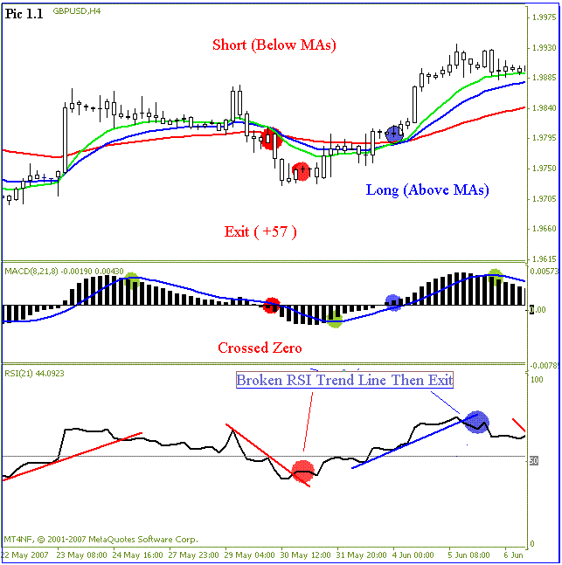
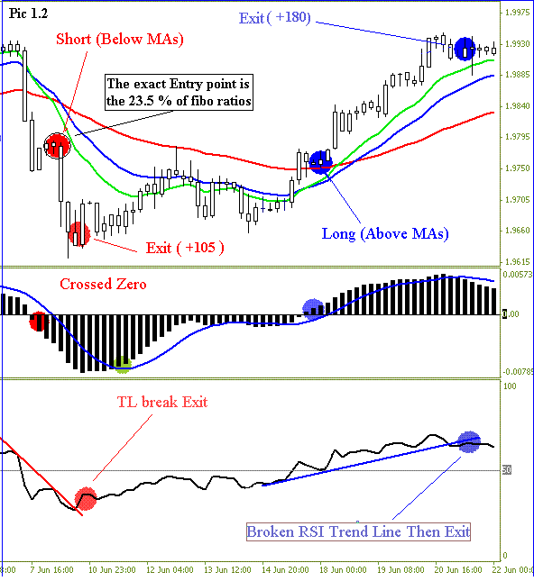
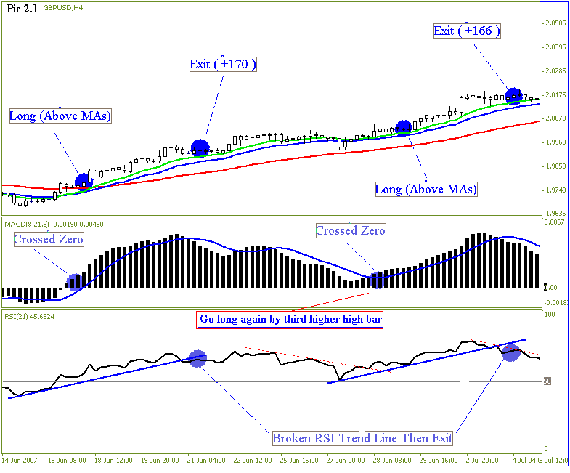
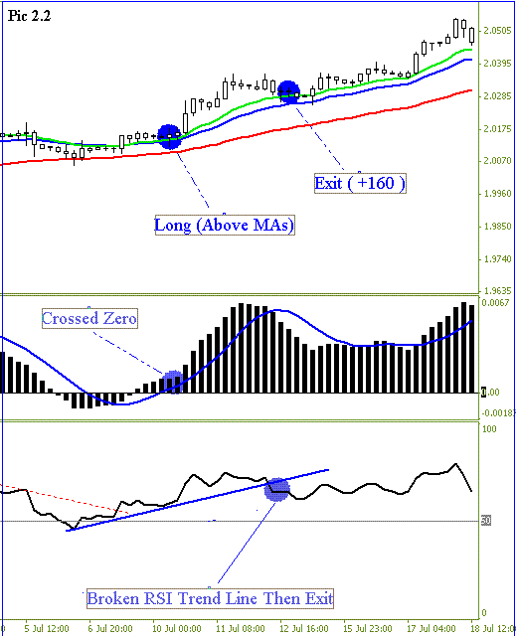
Key Notes:
- In fast moving market situations (when the signal confirm after one or two long candles) wait till the price bounce back to correctional level of % 23 Fibo and then enter the trade.
- Most reliable signal confirms when the RSI running Above / Below 50 line when you go for a Long / Short.
- A break of RSI Trend Line confirms when the second candle opens on the suggested direction.
- Don't ever take the trade unless the second bar opens Above / Below MACD zero line for a Long / Short trade while the MACD signal line will just give you an in advance alert to be ready for the trade.
- Once again, the cross over of MACD Value and the Signal Line will warn of a potential trade but don't ever take it unless you have your own reasonable reasons to do that.
- If you get out of a Buy trade upon an Exit signal, you can go for an immediate SHORT trade with a 50 point Target (Take Profit) and if the trade hit 50 point target while another SELL signal confirms, just follow the signal and go for the second SHORT. And vice versa, if you get out of a SHORT trade.
- Don't ever take second trade of LONG / SHORT in line with the first trade order type unless a FRESH signal of aforementioned conditions confirm to trade.
- Don't ever risk more than % 5 of your account balance unless you have your reasonable money management rules that suite you.
- Avoid the side markets by observing a narrowed Bollinger Bands or flat RSI line.
- Place the Stop Loss 10 pips Above / Below of Bearish / Bullish Parabolic SAR first appeared dot or 10 pips Above / Below the current Resistance (R2) / (S2) Support levels.
- Most of the false signals come when you trade against the major trend of the market. To know how to define the major trend use bigger time frame like daily or even weekly chart and apply the same setup on that chart to know what is probably the right direction of the market. Sometimes when the price touch the 55 EMA line react as a support or resistance level and at the same time you may have a trading signal against this fact. In this case you are probably against the major trend.( Pic.3)
- Exit the trade as soon as you see the clear signals (Don't be too optimistic when the market tell you another story. Exit the trade if you want to win)
- Don't hesitate to apply what the system show you while an over guess trader normally lose money.
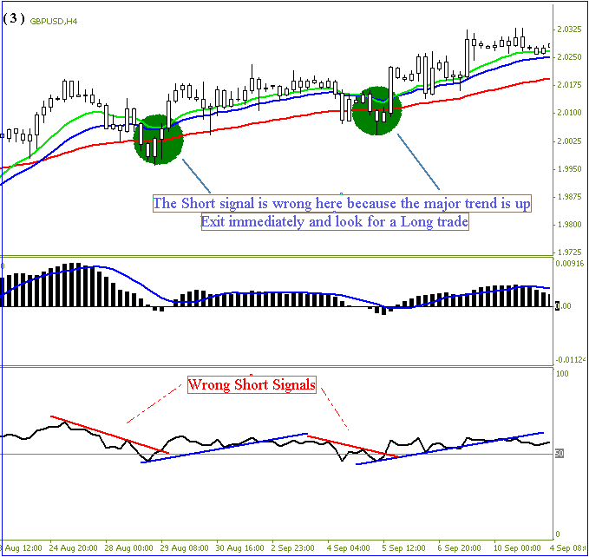
Be relax, don't risk too much and stick to the plan. Also I don't want to leave you alone to process everything by yourself as you can email me to s.a.ghafari@iftc.ir and I will do my best to answer you.

S. A Ghafari
FX Analyst


